**目 录**

What time do you go to school 3

Where is your pen pal from? 9

End rhyme 14

How often do you exercise？ 19

Do you want to watch a game show？ 25

Will people have robots？ 31

Have you ever been to a museum? 37

What’s the matter？ 43

Could you please clean your room？ 48

What were you doing when the rainstorm came ？ 53

# What time do you go to school

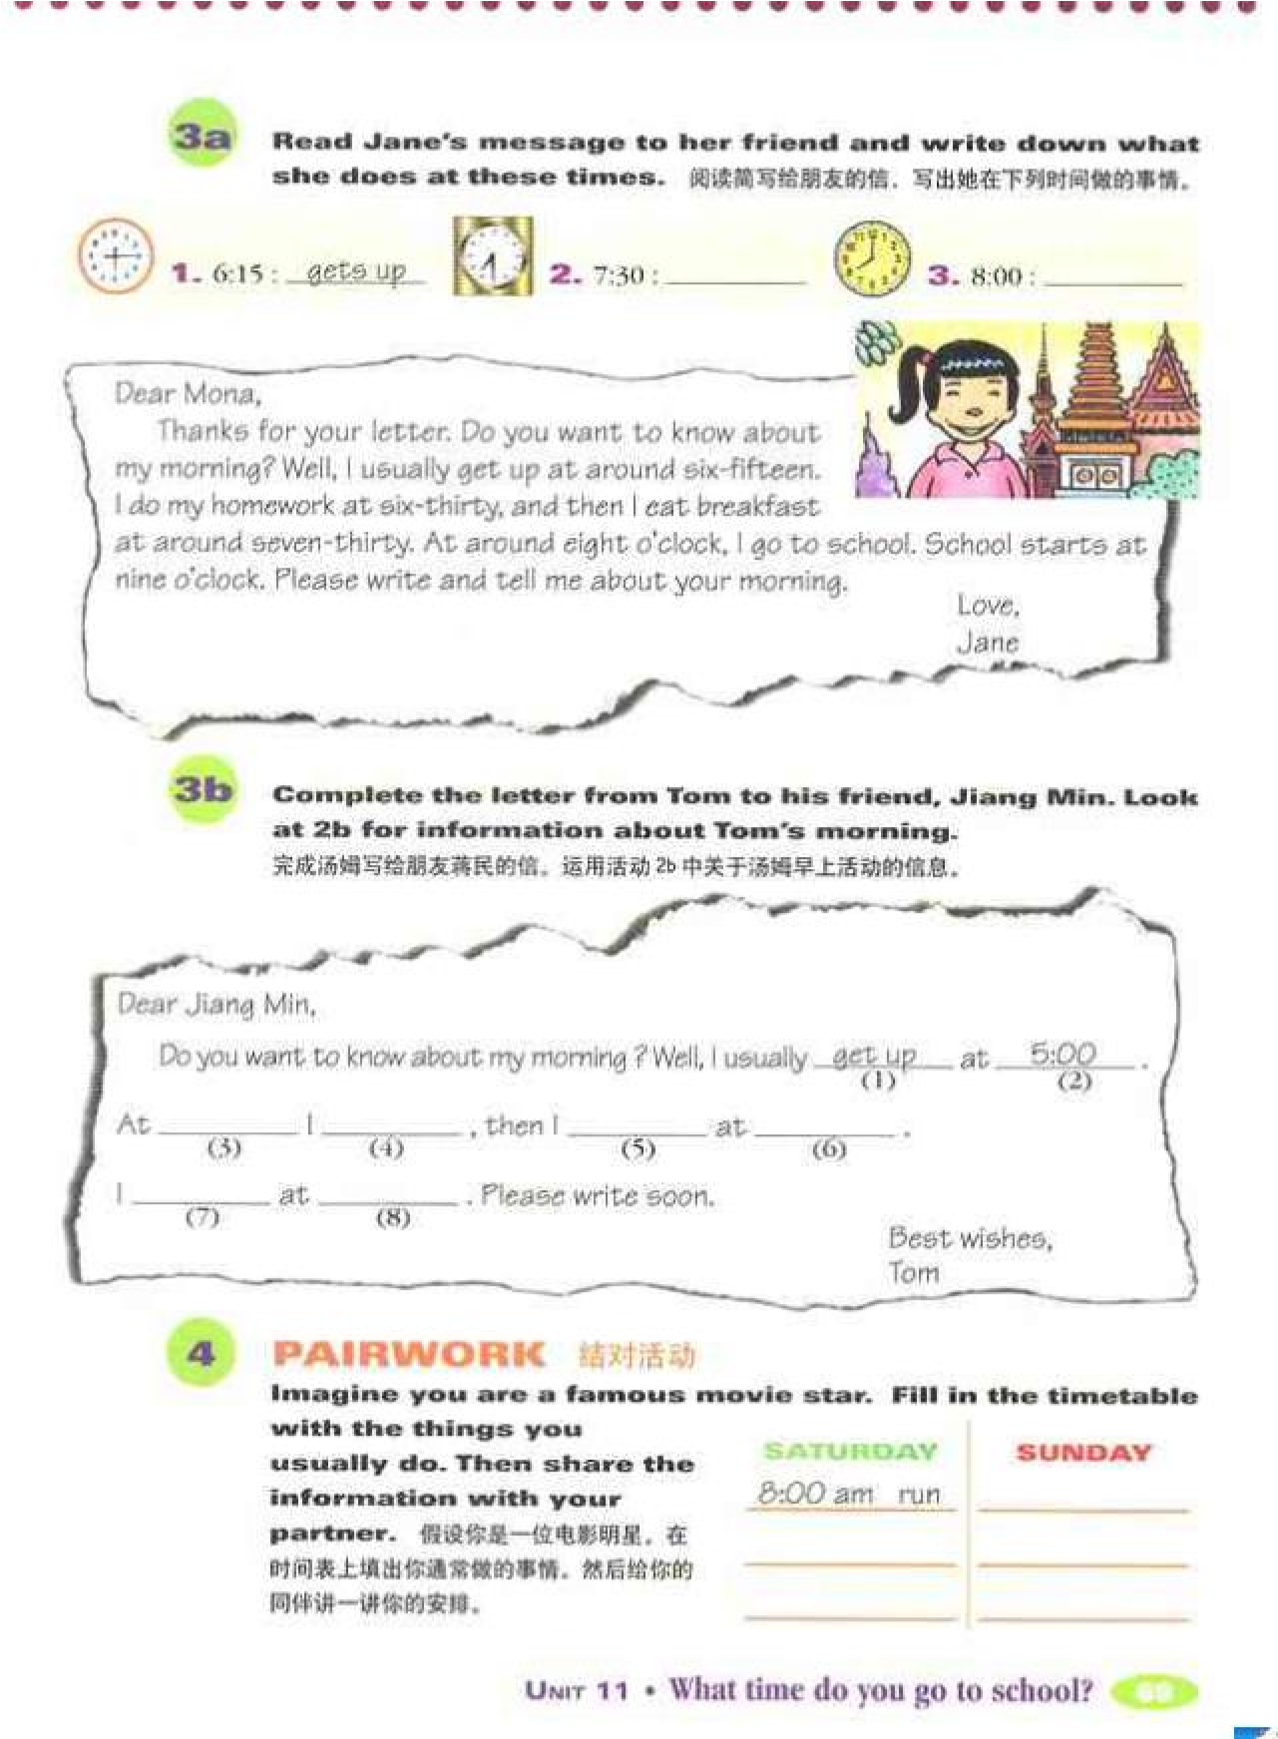

试讲要求：（1）朗读一遍

（2）设计阅读教学活动

（3）适当板书

Class Type: reading class

Period: Section B:3a-4

Teaching Objectives

1. Knowledge objectives

Grasp the phrases like get up, go to school, eat breakfast, do homework„

Be able to master the sentence pattern Sb. either do/does„or do/does

Enable Ss to understand the meaning of usually, always and sometimes and use these words to describe their daily life.

1. Ability objectives

Learn to use the passage to guess the meaning of usually, always and sometimes.

Be able to understand the main idea and some details of the dialogues by skimming, scanning and intensive reading.

1. Moral objectives

Enhance Ss’ awareness of the importance of learning to do time planning and have a good habit.

Teaching Key Points

1. Review some phrases and understand the passage.
2. Be able to master the reading skills of skimming, scanning and intensive reading.

Teaching Difficult Points

Enhance Ss’ awareness of the importance of learning to do time planning and have a good habit.

Teaching Procedures

Step 1 Warming up & leading in

Show Ss a video clip of a human’s daily life from getting up to fall asleep.

After watching the video, divide Ss into 4 groups to discuss the following question. Then report the results to the teacher.

T: Do you think this human’s day is good or not?

S1: „ S2: „

Step 2 Pre-reading

Show the pictures of Tony and Mary and ask Ss to guess what their daily lives are.

Firstly, teacher introduces some habits of them.

Secondly, ask Ss to guess.

T: Which ones do you think belong to Tony and which one belong to Mary?

S1: S2:

Step 3 While- reading

Task 1 Skimming

1. True or False

Make a form and list some simple sentences extracted from the passage and Ss should finish it by themselves.

1. Then ask some Ss to write their answers on the blackboard

and the one who gives all right answers gets some bonus.

|  |  |  |
| --- | --- | --- |
| Questions | True | False |
| Tony like eats hamburgers. |  |  |
| When Tony gets home, he watches TV  first. |  |  |
| „ |  |  |

Task 2 Scanning

1. Guess the meaning of usually, always and sometimes.
2. Listing

Ask Ss to list Tony and Mary’s habits under their names.

Tony Mary

Task 3 Intensive Reading

1. Help Ss to understand the sentence pattern Sb. either do/does„or do/does and ask Ss to make up new sentences.
2. Ask Ss to draw schedules for Mary and Tony in groups and present it in front of the whole class. Pay attention to different

Ss and encourage them to join in the activity.

1. Read out loud the passage together.

Step 4 Post-reading

Organize a little drama on the topic of “A day of my life”. Phrases and sentence pattern learned should be used in their presentation.

Step 5 Summary

Ss will summarize the language points learned in this lesson and teacher makes supplement timely.

T stresses that Ss should arrange their time well in daily life and to be a good time planner.

Step 6 Homework

Ss are encouraged to make a time schedule of one day by themselves. They are supposed to share the schedule in next class.

# Where is your pen pal from?

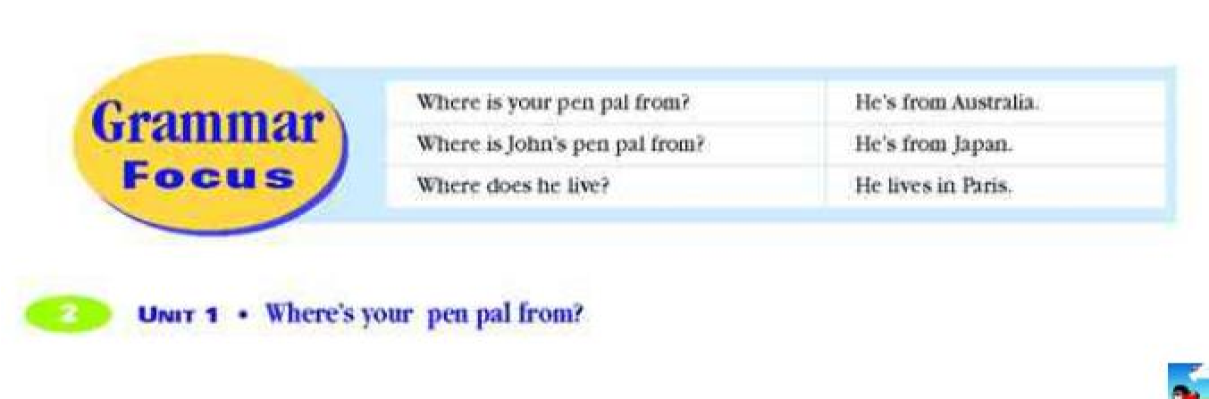

试讲要求：（1）朗读一遍

（2）设计语法教学活动

（3）适当板书

Topic: Countries, nationalities, and languages

Period：1a----Grammar Focus

Teaching Aims:

Knowledge Aim:

Ss can use the words about countries, languages. Talk about countries, nationalities and languages. Ask and tell about where people live

Ability Aim:

Where is she from? She is from....

Where does she live? She lives in....

What language does she speak? She speaks....

Emotional Aim:

Forster Ss’ sense of cultural awareness. To motivate ss’ cross-culture communication skills.

Key points:

Where is your/John's pen pal from? He/She is from...

Difficult points:

Pay attention to the “s” in third person singular.

e.g. Where does he/she live? He/She lives in....

## Teaching Steps:

Step 1 Leading-in

The information of the teacher's own pen pal's information.

"I have a pen pal. His name is Curry Murray. He is from the United States. Do you have a pen pal? Where is your pen pal from? What's your pen pal's name?"

Different students say the information about their own pen pals. T should choose the different countries. T writes the different countries on the Bb(both Chinese and English)

Step 2 Learning

Section A 1a

Learn the new words on the Bb. The new words are:

pen pal; Canada; France; Japan; the United States(the US/the

USA/America); Australia; Singapore; the United Kingdom(the

U.K./Great Britain/England)

Pay attention to the pronunciation of the new words.

Step 3 Listening

1b Listen and circle the countries in 1a they learned

Step 4 Competition

Two groups of students to write the new words to see which group does better. First write down the Chinese words with looking at the English meanings, then write down the English words with looking at the Chinese meanings.

(This step is a memory game. It can help the Ss consolidate the new words they learned)

Step 5 Pair work

1c Practice the following conversation:

---Do you have a pen pal? ---Yes, I do.

---Where's your pen pal's from? ----He/She is from ....(Write it on the Bb)

First T has a conversation with one student as an example then let the Ss practice in pairs. At last let several pairs do it again in class.

Step 6 Leading-in

Revise the countries names with looking at the Bb. Then T writes down the city names on the Bb. Let the Ss try to find out which countries the cities are in. The city names are following:

Toronto; Paris; Tokyo; New York; Sydney; Singapore; London; Step 7 Learning

2a Learn the city names together with the whole class just like Step 2

2b Listen and circle the cities and countries

2c Listen and complete the chart

Have a similar competition to consolidate the new words in this part.

Step 8 Pair work

T has a conversation with one student like the following:

---Do you have a pen pal? ---Yes, I do.

---What's your pen pal's name? ---His/Her name is....

---Where is your pen pal from? ---He/She is from... ---Where does he/she live? ---He/She lives in....(Write it down on the Bb)

Let the Ss practise after the T's example in pairs then several pairs do it in class.

Step 9 Exercise

My pen pal is from Australia.(划线提问)

John's pen pal is from Japan. (划线提问)

He lives in Paris. (划线提问)

Homework:

Read and copy the new words .

Copy the sentences in Grammar Focus

Make up the questions about Jodie in 2c The questions are: Does Jodie have a pen pal? Where is Jodie's pen pal from? Where does he/she live? What's his/her name?(This one can be chosen by themselves)

# End rhyme

试讲要求：（1）朗读一遍

（2）设计语音教学活动

（3）适当板书

## Lead in

First enjoy a song with the lyrics on the screen.

[*try to remember*](http://www.baidu.com/s?wd=try%20to%20remember&hl_tag=textlink&tn=SE_hldp01350_v6v6zkg6) *the kind of September when life was slow and oh so mellow* [*try to remember*](http://www.baidu.com/s?wd=try%20to%20remember&hl_tag=textlink&tn=SE_hldp01350_v6v6zkg6) *the kind of September when grass was green and grain was yellow try to remember the kind of September when you were a tender and a callow fellow try to remember and if you remember then follow -follow, oh-oh*

*try to remember when life was so tender that no one wept except the* [*willow*](http://www.baidu.com/s?wd=willow&hl_tag=textlink&tn=SE_hldp01350_v6v6zkg6)  *try to remember the kind of September when love was an ember about to billow try to remember and if you remember then follow-follow, oh-oh*

…

This is a classical American song, *Try to remember*. It gives us a soft and warm feeling, how does the song express this feeling? Let’s look at lyrics on the screen, pay attention to the end of each line. Yes，There are some, uh, we can call it techniques， that is, it repeats several sounds in the end of each line,

We call it end rhyming

## Presentation

End rhyming means repeating and playing upon the same letter at the end of each line. who can find it? Yes, At the end of line 1and line3, the words September, remember, tender, rhyme [ə]. At the end of line 2and line4， Mellow, yellow, fellow, willow, billow rhyme [əʊ]. In the first line try to

[remember](http://www.baidu.com/s?wd=try%20to%20remember&hl_tag=textlink&tn=SE_hldp01350_v6v6zkg6) the kind of September, remember and September also rhyme [ə].

End rhyming is widely used in poems or songs, which helps easy to remember, listeners find it unforgettable. And it shows the beauty of rhythm, and makes poems or songs more impressive. What is more, it also helps express the unique feeling inside, despite in September, there is no bleak but joy and warmth of harvest.

Meanwhile, End rhyming can be seen in poems, and the most common pattern is aabb, for example, let’s analyze the following poem.

*Ask me no more where Jove bestows a*

*When June is past, the fading rose; a*

*For in your beauty‘s orient deep b*

*These flowers, as in their causes, sleep. b*

Line 1,2 rhyme [əʊ]

Line 3,4 rhyme [i:p]

## Practice

Nowadays. End rhyming is also used in our daily life. Now, let’s analyze the following sentences.

1.No pain. No gain.

2. East and west, home is best.

3.It’s pay day today.

4.The downtown area is a scene of hustle and bustle.

5.Thinking is one of the most wonderful and powerful tools.

Now work with your partners and find out the end rhyming in each sentence.

You are required to finish the task in 10 minutes.

1. pain and gain rhyme [eɪn]
2. East west and best rhyme [st]
3. pay day today rhyme [eɪ]
4. hustle and bustle rhyme [ʌsl]
5. wonderful and powerful rhyme [əfl]

## Consolidation

1.Can you list some songs with end rhyming? Song 1:*I can see the first leaf falling, it’s all yellow and light, it’s so very cold outside, like the way I’m feeling inside.*

——*Big big world*

**Song 2:***Listen to the rhythm of falling rain,*

*Telling me just what a fool I’ve been, I wish that would go and let me cry in vain, And let me be alone again.*

*------the rhythm of falling rain*

2.Play a game called Waterfall

That is, each of you make a sentence with the same end rhyming one by one,

like this:

S1:It’s Friday, I’m happy today.

S2:But my girlfriend took my heart away when she’s away.

S3:Anyway, I will give her much prey.

S4:…

## Summary

## …

## Homework

Can you make some sentences by using beginning rhyming and end rhyming?

Try to work in groups, then write down your results.

**P.S.** 头韵alliteration，beginning rhyme

Besides the end rhyming, there is another form, beginning rhyme（alliteration）. it means repeating and playing upon the same letter at the beginning.

Safe and sound 平平安安

Soothing, Sensuous, Fragrantly Fragrant 安心安神，赏心悦目

Time and tide wait for no man. 岁月不等人。

Coca-cola, clean-clear, Rolls-Royce

Pride and prejudice 傲慢与偏见

# How often do you exercise？

Section A （1a 1b 1c）

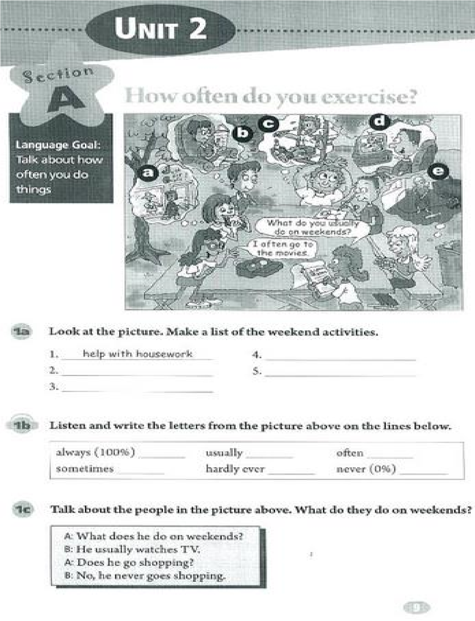

试讲要求：（1）朗读一遍

（2）设计听说教学活动 （3）适当板书

（**Warming up and leading in**）

T: Good morning every one, how are you today?

S: Fine, thank you! How are you?

T: I am fine, too, sit down please.

T: Boys and girls, what did you do last weekend?

S1: I went to the supermarket and bought some meat.

T: Quite good! You learned how to use the past tense. What about you, Lily?

L: I stayed at home and did my homework.

T: you are excellent! Sit down, please.

T: class, what do you usually do on weekends?

S2: I usually go to see a movie.

S3: I usually do some exercises.

T: yes! Today, we are going to learn “How often do you exercise?”

(Write down the title)

（**Presentation and Practice**）

T: look at the pictures on page 9, what do they do?

S4: watch TV，read books，exercise……

T: you are right, and anyone else?

S5: go shopping、go to movies.

T: Ok, now I need you to write down the answer on the book, pay attention to the pronunciation, am I clear? I will give you 3 minutes.

T: Now time is up, you can check your answers with your desk mates.

T: Let’s look at the words below, these are all the words of frequency, but not the same, do you want to learn them today?

S: Yes!

T: Very good! Listen to the tape and fill the percent after the words; it may help you to tell the difference of these words.

T: Read after me, please.

T: Always, usually, often, sometimes, hardly ever, never

S: Always, usually, often, sometimes, hardly ever, never

T: Now let’s play a game, I read in high voice, and you read in low voice, am I clear? Let’s go!

T: could you read the words by yourselves?

S: Yes!

T: Tim, do you want to have a try?

T: Always, usually, often, sometimes, hardly ever, never.

T: let’s give him a big hand!

T: boys and girls listen to me carefully, how often do you watch TV? I will repeat, how often do you watch TV? Who want to ask my question?

S5: I sometimes watch TV.

T: not bad, sit down please, Lucy, How often do you watch TV?

S: I watch TV every day.

T: very well, sit down please.

T: Please practice the conversation 1c with your partner.

（**Consolidation**）

T: Do you want to be a surveyor? I will give you a task; you need to make a survey about” what do you usually do on weekend, and how often do you…”, ask at least 3 students in our class and then share with us.

T: who want to show your survey? Kate, please come here.

K: Jim often plays basketball on weekend, Lily does the homework on weekend, and Tom often goes to supermarket.

T: You are the super! Let’s give her a big hand! Anyone else wants to try?

Belly!

（**Summary**）

T: Boys and girls look at the blackboard again, and who can tell me what we have learned today?

S5: Today we learned the sentence “how often do you…” and how to answer it.

T: Yes! Today we learned some frequency words. Do you remember, let’s read them again.

T: I’d like to give you a gift because you are very active today.

T: Ok, today’s homework for you is to write a short passage with the title“my weekend”. And we will talk about it next class. I will say this again… Are you clear?

S: yes!

T: Well, class is over, goodbye!

S: Good-bye teacher!

（板书设计）

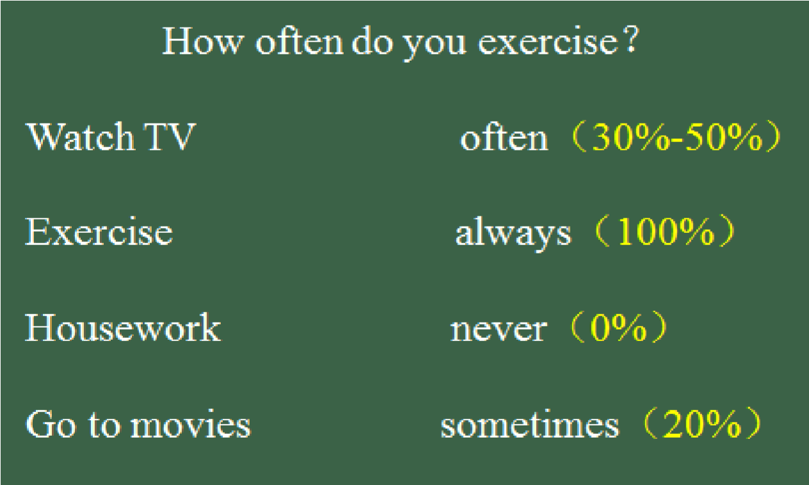

# Do you want to watch a game show？

Section A （1a 1b 1c）

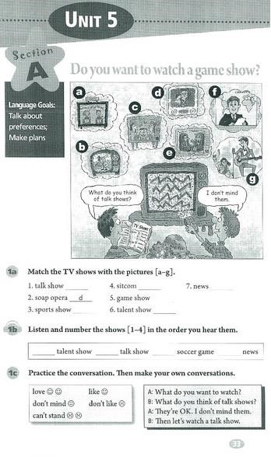

试讲要求：（1）朗读一遍

（2）设计听说教学活动 （3）适当板书

（**Warming up and leading in**）

T: Good morning every one, how are you today?

S: Fine, thank you! How are you?

T: I am fine, too, sit down please. T:Boys and girls，do you like to watch TV？

S: yes!

T: Oh, I heard most of you say“yes”，well，What’s your favorite TV show？

S1: Talent show…

T: and… It doesn’t matter; let’s get to know them one by one, ok?

S: sure!

（**Presentation and Practice**）

T: ok, please look at the picture, what’s this TV show?

S2: kuai le da ben ying!

T: yes, who can tell me the English name?

S3: Happy Camp!

T: Good! Sit down, please, and this one?

S4:Dad, where are we going!

T: It seems you all watched it, right?

S: yes!

T: these TV shows are called game show.

T: read after me twice“game show”

S: Game show，game show.

T: Let’s look at some other TV shows.

S5: It’s the voice of China!

T: you are right! Which singer do you like best?

S5: I like Wu Mochou, because she has a lot of personality!

T: Oh, I like her too, and I like your performance.

T: this kind of TV show we call “talent show” S: Talent show!

T；Good，and I believe you are familiar with this… S: It is news!

T: Now, open your books and turn to page 33, look at the picture and match the

TV shows with the pictures. You can work in pairs.

T: Have you finished?

S: Yes!

T: Then who can tell us your answer, hands up please. The boy in black. S6: Talk show, e; soap opera, d; sports show, b; sitcom, c ; game show, a; talent show, g; news, f.

T: Is she right?

S: Yes!

T: You are super!!

（**Consolidation**）

T: Now, look at the screen. What do these faces mean?

S: love, like, don’t mind, don’t like, can’t stand.

T: Class. What do you think of talent shows?

S: Love.

T: Yes. We can say “I love them.” Can you read the sentences?

S: Yes. What do you think of talent shows? I love them.

T: work in groups and make a survey about “what do you think of game shows?” Ok, I will give you 5minites.

T: time is up; you group, please come here and show your work!

T: Great!

（**Summary**）

T: Boys and girls look at the blackboard again, and who can tell me what we have learned today?

S: Today we learned some name of TV shows.

T: Yes! And we also learned to express our feelings about these TV shows, right?

Do you remember, let’s read them again.

T: I’d like to give you a gift because you are very active today.

T: Ok, today’s homework for you is to write a short passage with the title“I love… ”. Choose one TV show you like, and write down at least 3 reasons, we will talk about it next class. I will say this again… Are you clear?

S: yes!

T: Well, class is over, goodbye!

S: Good-bye teacher!

（板书设计）

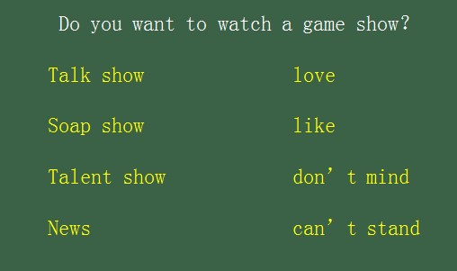

# Will people have robots？

Section A （1a 1b 1c）

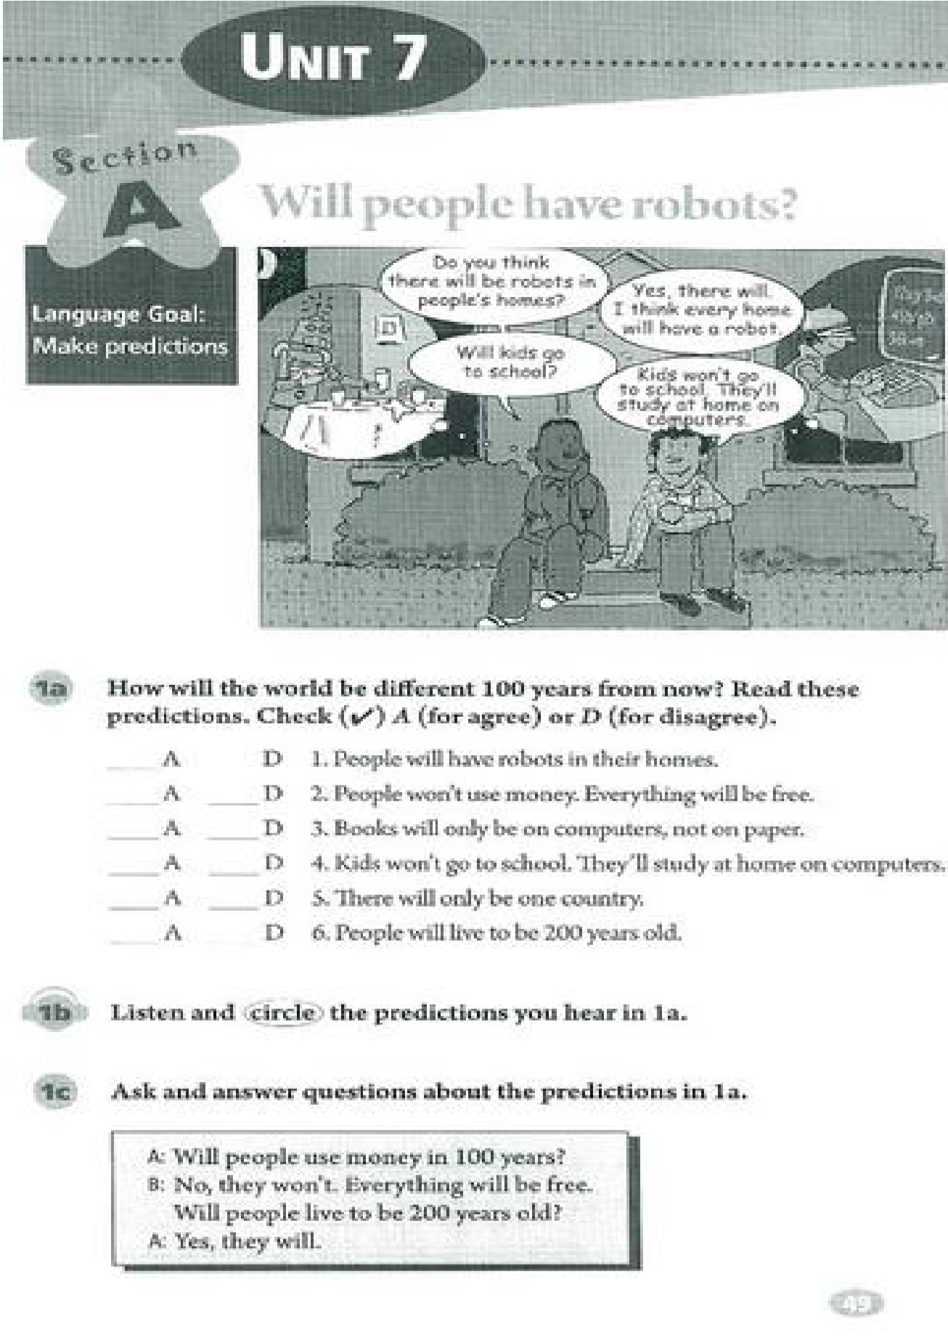

试讲要求：（1）朗读一遍

（2）设计听说教学活动 （3）适当板书

（**Warming up and leading in**）

T: Good morning every one, how are you today?

S: Fine, thank you! How are you?

T: I am fine, too, sit down please.

T: Boys and girls, what do you want to be when you grow up?

S1: I want to be a scientist.

T: Wow, that’s cool, how are you going to do that?

S1: I’m going to study science hard.

T: very well, sit down, please.

T: What about you, Jim?

J: I want to be a professional basketball player.

T: I hope you dream could come true.

T: You have told me your plans, but how will the world be different in the future, can you make some predictions?

S: May be a lot of robots.

T: Good! Let’s look at what we are going to learn today.

(Write down the title) （**Presentation and Practice**）

T: How old are you Lucy?

L: I am 14 years old.

T: ok, look at this time line, what about two years later?

L: 16 years old!

T: Good, we can also say“I will be 16 years old in two years，”could you follow me？

L：I will be 16 years old in two years.

T: yes! Now, let’s talk about what the future will be.

T: will books only be on computer?

S1: yes, they will.

S2: No, they don’t.

T: Oh, it is better to say“they will not”，“books won’t be only on computer”.

S2: Ok, I got it.

T: now you can discuss in pairs to finish 1a on page 49, am I clear?

T: who want to tell us your result?

S3: I think people will have robots in their homes, and people won’t use money, everything will be free.

T: excellent! Now let’s look at the pictures and read the sentences together, are you ready? Go!

T: boys read, girls!

T: you are super.

T: May be you are a little tired after reading. Now please close your mouths and open your ears, let’s listen to the tape and finish 1b.

T：Green，could you tell us what you hear？

G：1, 2, 4, 5

T：Is he correct？ S：Yes，he is.

（**Consolidation**）

T: do you want to be a artist? Please work in groups to make predictions with the sentences in 1C and drawing them down. You can add other sentences if you like, I will give you 5minites.

T: Ok, time is up. Which group wants to show their future life?

S4: In our picture, people won’t use money in 100 years, and there will be only one country, called“Human United States”.

T: Great！Let’s give this group a big hand！

（**Summary**）

T: Boys and girls look at the blackboard again, and who can tell me what we have learned today?

S: Today we learned to predict future things.

T: Yes! And we learned to express “will be”right? Do you remember, let’s read them again.

T: I’d like to give you a gift because you are very active today.

T: Ok, today’s homework for you is to write a short passage with the title“the future life”. we will talk about it next class. I will say this again… Are you clear?

S: yes!

T: Well, class is over, goodbye!

S: Good-bye teacher!

（板书设计）

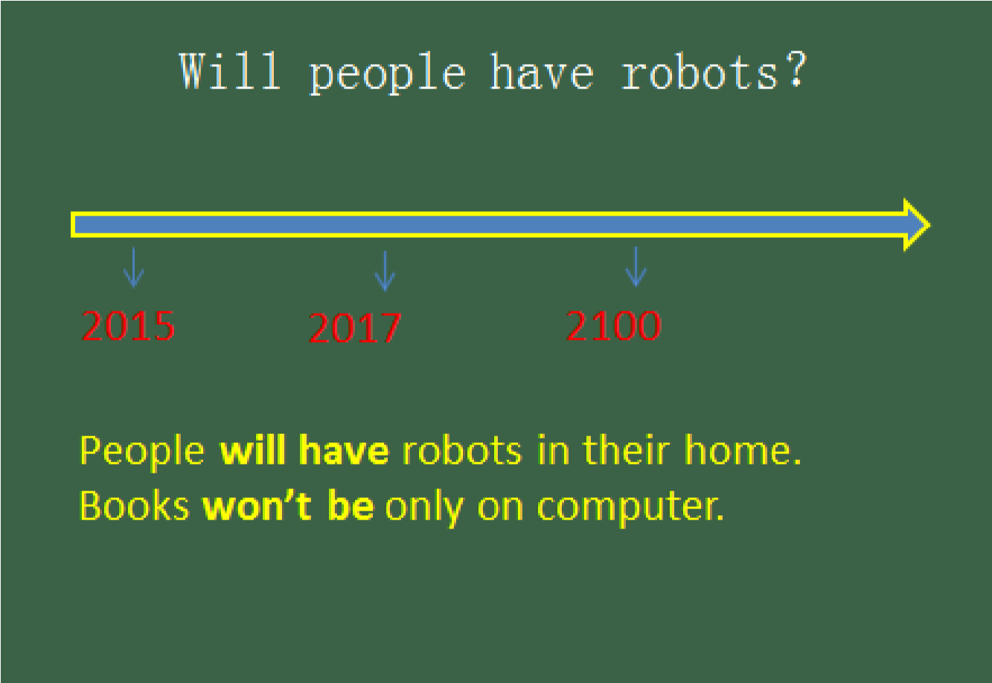

# Have you ever been to a museum?

Section A （3a 3b 3c）

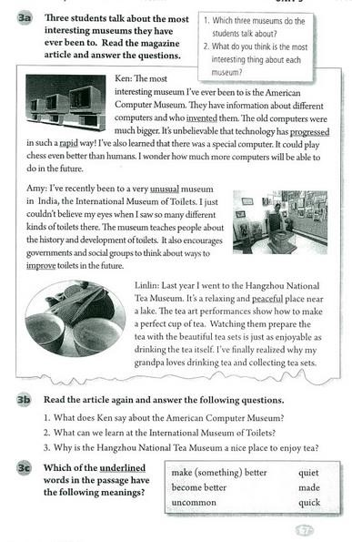

试讲要求：（1）朗读一遍

（2）设计阅读教学活动 （3）适当板书

（**Warming up and leading in**）

T: Good morning every one, how are you today?

S: Fine, thank you! How are you?

T: I am fine, too, sit down please.

T: Ok, boys and girls, let’s look at the pictures on screen and review what we learned last class.

T: Have you ever been to the Great Wall?

S1: Yes, I have.

S2: No, I haven’t.

T: Have you ever been to a museum?

S3: Yes, I have.

T: Which museum did you go?

S3: I have been to the National Museum in Beijing.

T: Very good, sit down, please.

（**pre-reading**）

T: Before our reading, please write down the kinds of museum you know.

T: Ok, please share your answers.

S4: History museum, computer museum, nature museum!

T: Great, anyone else? The girl in red coat, you please.

S5: art museum, film museum.

T: Very well, today we are going to know another three museums.

T: Are you ready, let’s go!

（**while-reading**）

T: Now please skim the passage, do not read sentence by sentence, and then tell me the full name of each museum. Three minutes for you.

T: Time is up, who’d like to tell me your answer? Ok, Lily, please.

L: they are the American computer museum, the International museum of toilets, and Hangzhou Tea museum.

T: is she correct?

S: yes!

T: nice work, sit down, please.

T: Here comes a task, I need you to scan the passage again and do some“T or F”exercise，am I clear？ If you find the answer，please hands up.

T: listen to me carefully; American Computer Museum only has information about different computers there. True or false?

S6: false!

T: why do you think so?

S6: American Computer Museum only has information about different computers and who invented them.

T: excellent, let’s give him a big hand.

T: Ok, one more time, India has the most advanced toilet. True or false?

S7: True.

T: are you sure?

S8: False.

T: class, whom do you think is right?

S: False! It did not mention in the passage.

T: well done!

T: This time, I will divide you into 2 groups, there is a PK between you two group, and I will see which group is faster to find all the answers of 3b, go!

S: we find the answer!

T: It seems group 2 is faster, ok, tell us your answer!

T: you all did a good job, and finish our task well, group 1, next time, I believe you could do better!

（**post-reading**）

T: After reading this passage, we know some museum. And we will make a discussion “what do you think is the most interesting thing about each museum?” I will give you 5minutes and then we share the opinions.

T: Are you finished?

S9: The tea art performance is the most interesting thing in Hangzhou Tea museum.

T: You all express your opinions, I am so proud of you!

（**summary**）

T: You all did a good job today; I love your performance, let’s look at the blackboard and see what we learned today.

S: we learned some different museum.

T: Yes, and we also practiced the Present Perfect Tense, right?

S: Yes!

T: Today’s homework for you is to introduce the three museums to your parents.

Am I clear? I will repeat this again.

T: Well, class is over, goodbye!

S: Good-bye teacher!

（板书设计）

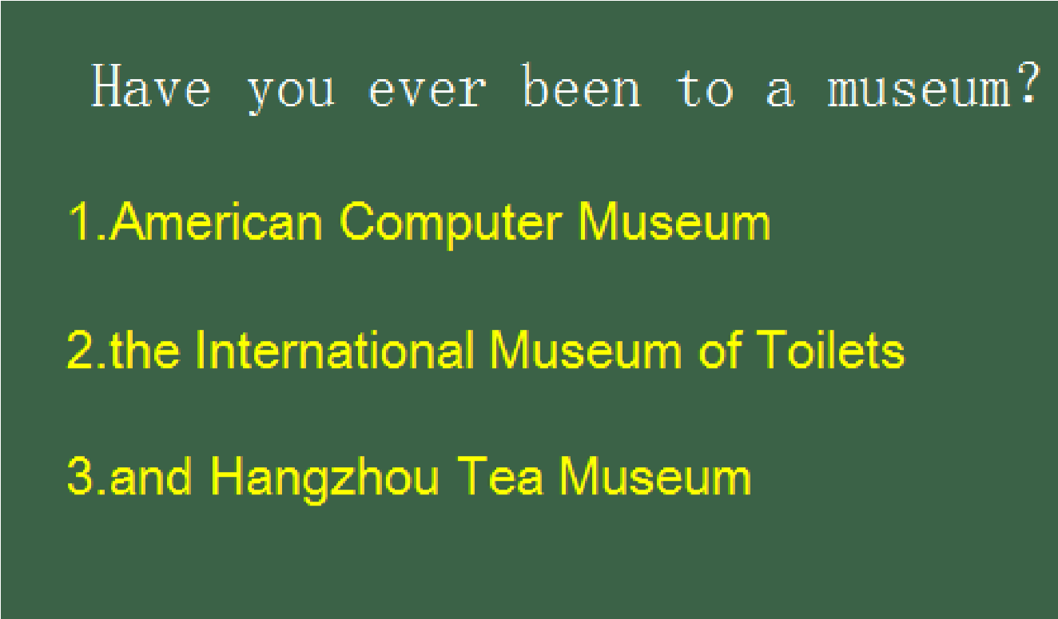

# What’s the matter？

Section A （3a 3b 3c）

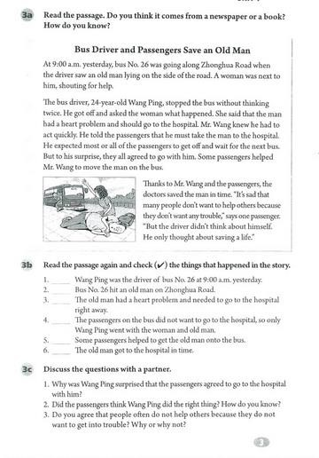

试讲要求：（1）朗读一遍

（2）设计阅读教学活动 （3）适当板书

（**Warming up and leading in**）

T: Good morning every one, how are you today?

S: Fine, thank you! How are you?

T: I am fine, too, sit down please.

T: Look at the picture, do you know about this event?

S1：It’s“ xiaoyueyue event”.

T: yes, a toddler was run over twice. For seven minutes she was ignored by 18

Passers-by. This is truly a tragedy to xiao yueyue and to our society.

T: So what will do when you meet this? Do you often help others?

S2: I will call the ambulance and ask the police for help.

T: That’s good choice. Let’s see what happened in our passage.

（**pre-reading**）

T: boys and girls, look at the title of the passage, could you guess it from a newspaper or a book?

S2: It is from a newspaper.

T: How do you know?

S2: It seems tell us a news and I read some titles in newspaper are just like this one.

T: Good, sit please. We will check your answer after reading the whole passage. （**while-reading**）

T: Now please skim the passage, do not read sentence by sentence, and I will give you a task, to check the things that happened in the passage, you can work in pairs. Three minutes for you.

T: Time is up, who’d like to tell me your answer? Ok, Lily, please.

L: 1, 3, 5 and 6 happened in the passage, while 2, 4 are not.

T: Is she all right?

S: Yes! She is.

T: Good, sit down, please.

T: And who can tell me what this passage about in one sentence?

S3: Bus driver and passengers saved an old man lying on the ground.

T: you are so smart!

T: Here comes the second task, I need you to scan the passage again and answer two questions, I will divide you into 2 groups, each group deals with one question, there is PK between you two group, and I will see which group is faster to find the answer, go!

S: we find the answer!

T: It seems group 2 is faster, ok, tell us your answer!

T: you all did a good job, and finish our task well, group 1, next time, I believe you could do better!

（**post-reading**）

T: After reading this passage, may be you have a lot of thought in your mind.

Now let’s speak out, if you see an old man fall down on the ground, what will you do?

S4: I will help him because I will also be an old man in the future, if I do not help him now; I think nobody will help me.

S5: I will not help him because some old people are not so kind, they will ask you for money, I do not have money, I am just a student.

（**summary**）

T: you all give me your reasons, I like your answer. Helping the old in trouble is a traditional virtue of Chinese; we should stick to it and develop it further, in a proper way.

T: Today’s homework for you is to act as a little reporter, ask three strangers their opinions on“will you help the old when they have trouble”，then write the answers down，we will talk about it next class. Am I clear? I will repeat.

T: Well, class is over, goodbye!

S: Good-bye teacher!

（板书设计）

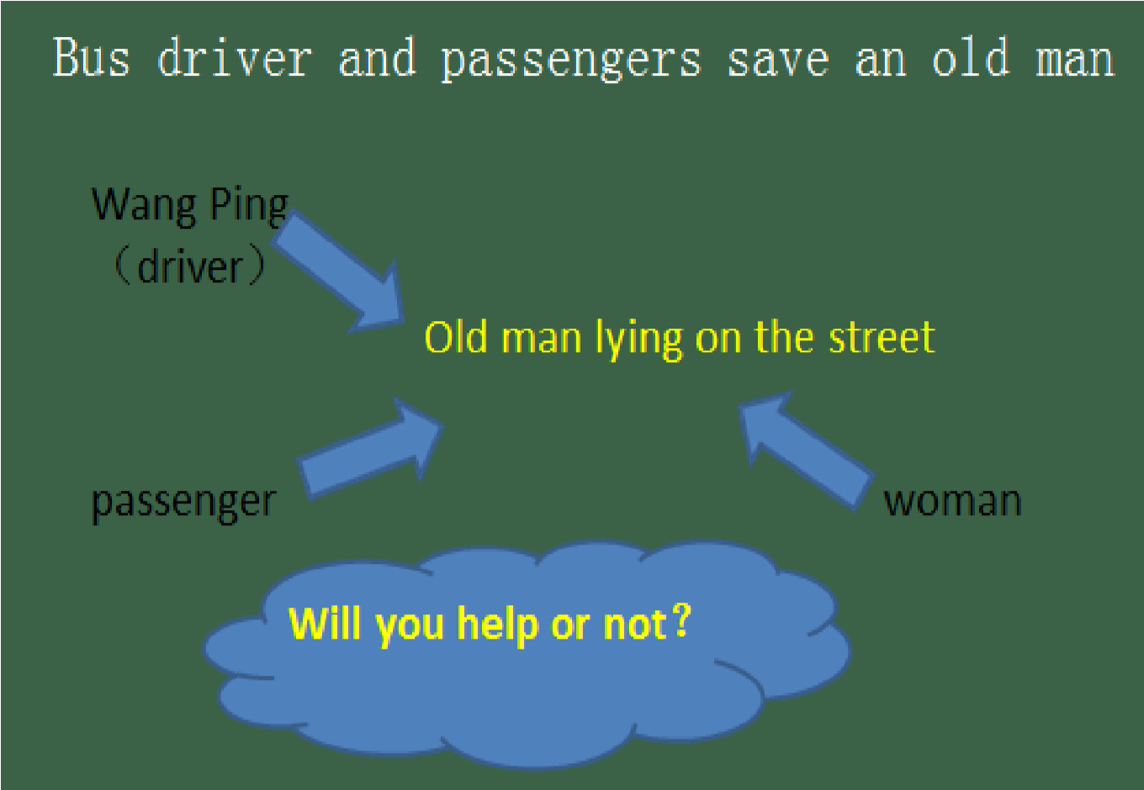

# Could you please clean your room？

Section A （3a 3b 3c）

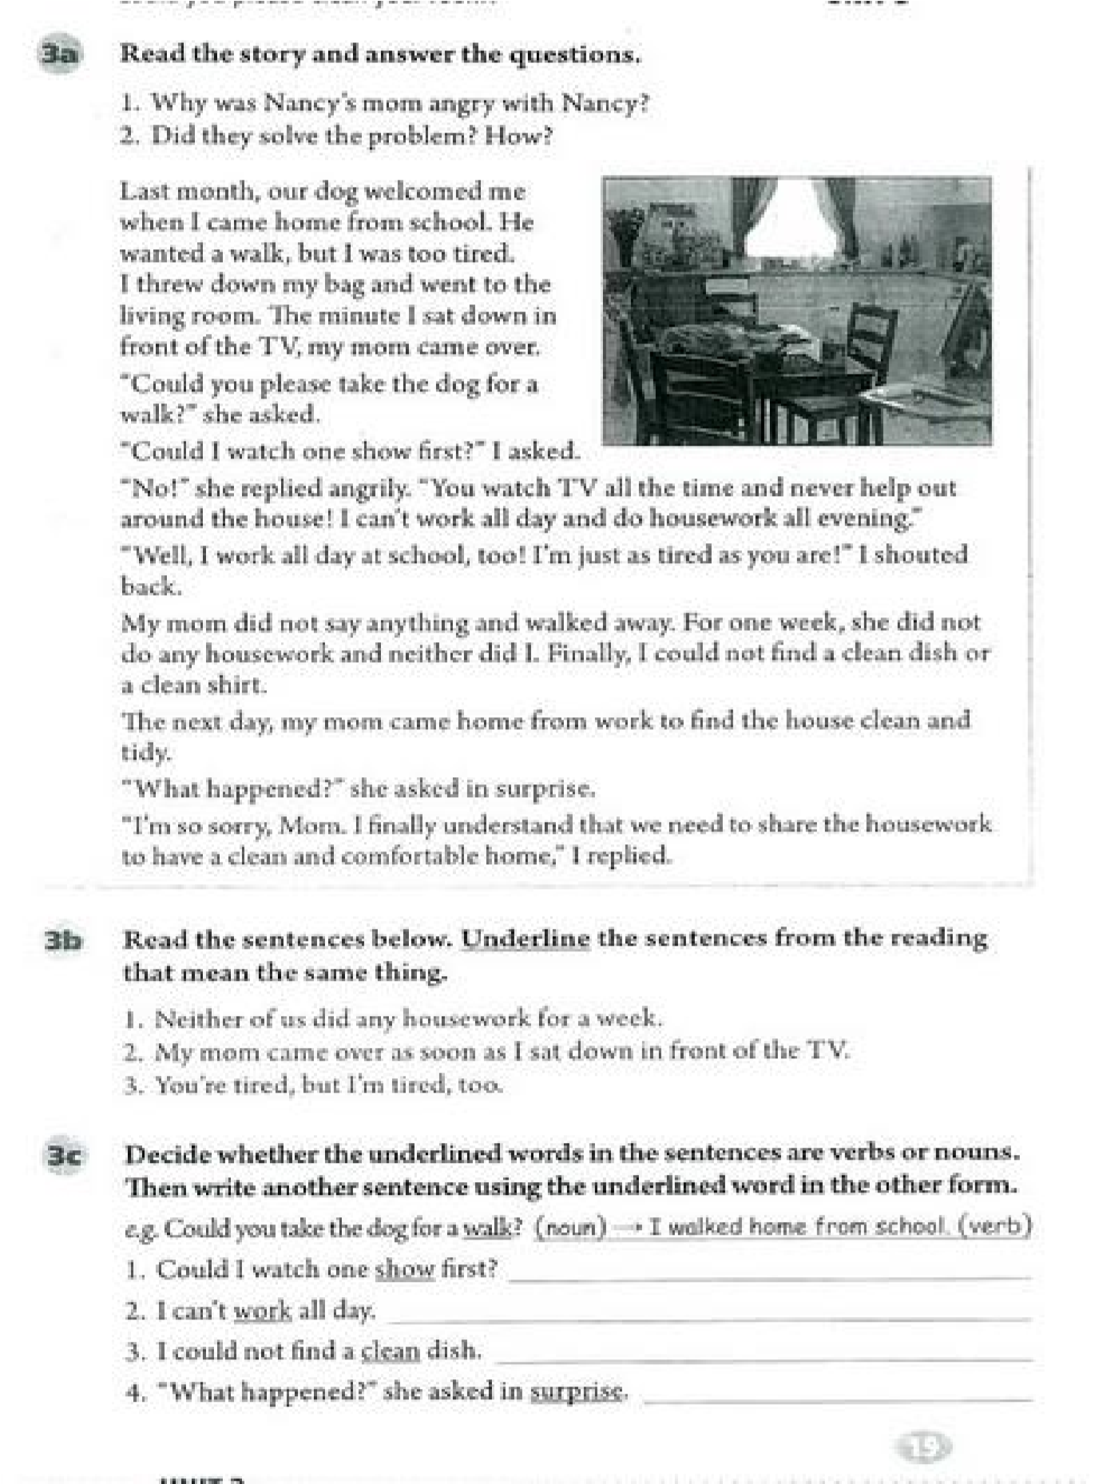

试讲要求：（1）朗读一遍

（2）设计阅读教学活动 （3）适当板书

（**Warming up and leading in**）

T: Good morning every one, how are you today?

S: Fine, thank you! How are you?

T: I am fine, too, sit down please.

T: Last class, we learned some phrases about house working, do you still remember?

S: Yes!

S1: take out the trash; clean the living room; and… T: not bad, who want to help him?

S2: Sweep the floor; make the bed; do the dishes.

T: very well, sit down, please. Could you make sentences with these phrases in past tense?

S3: Yes, I did some chores last weekend.

T: Great! Today we are going to learn a story about house working.

（**pre-reading**）

T: boys and girls, look at the picture on page 19, could you guess what this story about without reading the passage?

S3: It is about how to clean the room.

S4: It’s about family house working.

T: Good, your answers are all make sense, sit please. We will check your answers after reading the whole passage.

（**while-reading**）

T: Now please skim the passage, do not read sentence by sentence, since this is a story, please find the main characters, the place, what happened and the result, you can work in pairs. Three minutes for you.

T: Time is up, who’d like to tell me your answer? Ok, Lily, please.

L: The main characters are Nancy and her Mom.

S5: This story happened in Nancy’s home.

S6: Nancy did not want to do the house work, her mom was angry with her, at last, she did the house work.

T: Good, you are so smart! Sit down, please.

T: Here comes the second task, I need you to scan the passage again and answer two questions, I will divide you into 2 groups, each group deals with one question on page 19, there is a PK between you two group, and I will see which group is faster to find the answer, go!

S: we find the answer!

T: It seems group 2 is faster, ok, tell us your answer!

T: you all did a good job, and finish our task well, group 1, next time, I believe you could do better!

（**post-reading**）

T: After reading this passage, let’s do some exercise; please underline the sentences from the reading that mean the same thing.

T: Are you finished?

S7: for one week, she did not do any house work and neither did I.

S8: The minutes I sat down in front of the TV, my mom came over.

T: excellent, sit down, please.

（**summary**）

T: You all did a good job today; I love your performance, let’s look at the blackboard and see what we learned today.

S: we learned a story about Nancy.

T: Yes, and every family has a lot of housework, everyone should learn to do , am I right?

S: Yes!

T: Today’s homework for you is to make a conversation between you and your mother, using the sentence pattern ―Could you please …? Could I …? Am I clear? I will repeat.

T: Well, class is over, goodbye!

S: Good-bye teacher!

（板书设计）

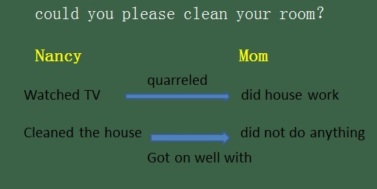

# What were you doing when the rainstorm came ？

Section A （3a 3b 3c）

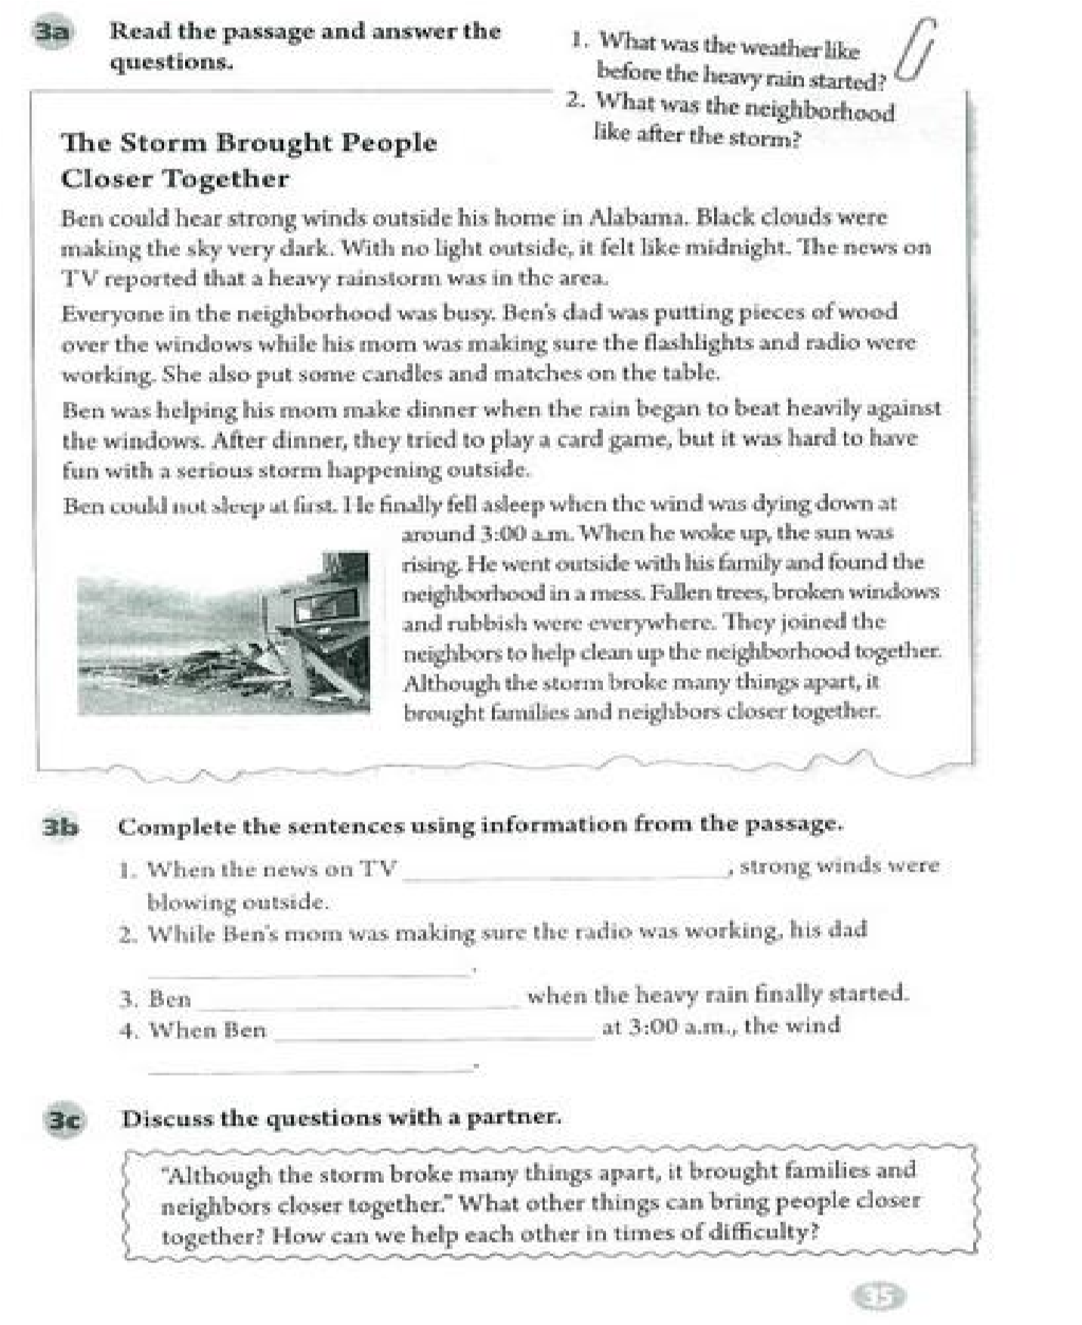

试讲要求：（1）朗读一遍

（2）设计阅读教学活动 （3）适当板书

（**Warming up and leading in**）

T: Good morning every one, how are you today?

S: Fine, thank you! How are you?

T: I am fine, too, sit down please.

T：How is the whether today？ S1: Today is sunny!

T: Do you like the sunny days?

S2: Yes, It is very warm and I can play outside!

T: How about the rainy days?

S3: I don’t like rainy days, because it is very cold.

T: Yes, and sometimes when it is windy strongly and rainy heavily we call it storm. And today we are going to learn a passage about storm.

（**pre-reading**）

T: boys and girls, look at the pictures on the screen, what was the whether like before the heavy rain started.

S4: I can see black cloud.

S5: I can see strong wind.

S6: I can see it becomes very dark.

T: Good, your answers are all make sense, sit please. And do you know what we should prepare before the storm?

S7: we should prepare matches, candle.

T: yes, very good. Let’s read the passage and see what they did in the storm. （**while-reading**）

T: Now please skim the passage, do not read sentence by sentence, and then tell me the main idea of each paragraph, you can work in pairs. Three minutes for you.

T: Time is up, who’d like to tell me your answer? Ok, Lily, please.

L: Paragraph 1 and 2 tell us the situation before the storm.

T: could you tell me a little bit specific? What were people doing?

S: Dad was putting pieces of wood over the windows.

T: Yes! And what about the next paragraph?

S8: the situation during the storm.

T: What was Ben doing when it rained heavily?

S: He was helping his Mom make dinner.

T: Good! And I think the last paragraph is talks about the situation after the storm.

T: Here comes a task, I need you to scan the passage again and fill the blanks in 3b, I will divide you into 2 groups, there is a PK between you two group, and I will see which group is faster to find all the answers, go!

S: we find the answer!

T: It seems group 2 is faster, ok, tell us your answer!

T: you all did a good job, and finish our task well, group 1, next time, I believe you could do better!

（**post-reading**）

T: After reading this passage, we know what happened before and during the storm. However, in the last paragraph, pay attention to the sentence“Although the storm broke away many things apart，it brought families and neighbors closer together”. What does this mean? You can work in groups and discuss it.

T: Are you finished?

S: We could encourage each other and help each other!

T: You all express your opinions, I am so proud of you!

（**summary**）

T: You all did a good job today; I love your performance, let’s look at the blackboard and see what we learned today.

S: we learned something about the storm.

T: Yes, and we also learned to help people in difficulty, right?

S: Yes!

T: Today’s homework for you is to read the retell the passage to your parents.

Am I clear? I will repeat this again.

T: Well, class is over, goodbye!

S: Good-bye teacher!

（板书设计）

